The Ni-Wumpf
System 80 CPU Mk II
Manual

Copyright 2017 Ni-Wumpf Ltd.

Revision B

Overview 4
Service 5
Design 5
Hardware 5
Software 5
Updating code on the CPU 5
Installation Caveats 6
Mounting... 7
Diagnostics and Bookkeeping 9
Onboard CPU Self Test 9
SETUP 9
DATA 11
HARDWR 11
OPTIOn 12
EXPErT 14
Monitor Console 16
Updating Code. 17
Troubleshooting 19
Warranty 22
Returning Your Board for Repair 22

Overview
“Well, and here we go again” – It’s not clear where this quote comes from, only that it seems to fit perfectly right where it is. And, for as long as I have been putting off writing this manual, it has been only these six words that have consistently been select candidates to begin this manual with. Every once in a while though, it would be gratifying to know just why things are the way they are, and what particular synapse had collapsed in a mind-bogglingly fiery suicide in order to present you, the reader, with this stimulating, yet irrelevant thought. It is interesting to note that a ‘Google’ search for these same words aimed at some hint at what repressed memory coughed up this persistent idea reveals absolutely nothing helpful, apart from a completely different tangent somewhere along the lines of George Bush quotes that apparently have a lot to do with a thought that I did not have in mind when I was quoting it.
“Brought to you by the makers of other fine products, like the Gottlieb System 1 CPU”. Better. More marketable. And much closer to the mark of what you would expect a manual to begin with, but still only relevant in the fact that both products from Ni-Wumpf have the word “CPU” in them. Aside from this similarity however, the products are pretty much nothing alike, which is nice if you like to write manuals, but quite frustrating when you have just determined that much of the work done previously along these same lines will not actually be of much help at all now.
All right then, let’s take a stab at an overview of what we’re dealing with here in the vain belief that whatever the big picture is, it is not at this time, armed as well, and will not in fact, be stabbing back. There are a lot of Gottlieb System 80 games out there, and a lot of titles as well: fourteen System 80 games, twenty System 80A games, and twenty-two System 80B games – if the Internet Pinball database project is accurate. This is good, and bad. Good, in that, there is a market for a replacement CPU here. Bad, in that, there is a lot of work to be done if one CPU is going to handle 56 very different titles. Late in 1999, when the seeds of this project were first sown, these were the very thoughts drifting around my already badly twisted imagination. Now, if you have any experience at all with our first foray into replacement pinball components, (let’s be immodest here - the first replacement CPU ever to hit the market,) you may remember that Ni-Wumpf does things, well, differently. There are a lot of reasons for this – none of them spectacularly valid enough to convince anyone else but the principles of the company that, indeed this is the way to go about releasing a CPU to support pinball games whose original brains have melted. However, were you fore-armed with that experience, it should not then, surprise the reader, that this new CPU should be completely askew, and far beyond the imagination of what a normal approach would take to tackling the issue of; “how do we design a CPU that can be flexible enough to support three architectural implementations, and yet adaptable enough to handle 56 different code variants”.
Heh, heh, heh… truly, I wish I had majored in chemistry instead of computer science, because the imagery of bubbling beakers, and crackling flames would really be much more appropriate here than any mental picture I could conjure up to portray what goes on in creating these things. I mean, how entertaining can design workstations, scattered electronic components, and old moldy Dunkin’ Doughnuts coffee cups really be in preparing the reader for what actually went into the board currently in their possession? It’s no wonder then that there are no movies about computer scientists, because despite the word “scientist” in the title, the role is completely unappealing to the Hollywood screen guild. No amount of bizarre adjectives clustered around any marquee touting the phrase “computer scientist” is likely to interest the average 14 yr. old looking for stimulating adolescent entertainment. Just as well, in this case, because, it is largely not this audience for which this manual was written for and the feeling that once engendered this sudden train of thought regarding the media marketing appeal of computer professionals has now, thankfully, passed.

Service
The board is designed with as many surface mount components as possible to take advantage of the cost and availability of complex high-pin count components. These components form the core hardware functionality of the board – physically and electrically. However, at the edge of the logical output from the board, where the CPU interfaces directly with the hardware of the pinball circuitry, the position is reversed - all PTH components were used. In this way, the architecture utilizes a high-density set of core surface mount components inside surrounded on the outside by PTH interface components that protect this circuitry from damage. Think of this along the lines of the 1970’s “big fig newton” commercial: “ooey, gooey, rich and chewy inside, golden crunchy, nice and munchy outside.” Any damage that can be directed to the board from faulty driver board components, mysterious cabinet re-wiring, and plain operator error is going to wind up on these “buffer” components that can easily be serviced in the field with standard available parts. At no point should the surface-mount components need to be replaced. It is this design philosophy that should provide a blend of the best characteristics from each era of electronic component design to provide the user with a high density circuit design that can easily be serviced by the operator.

Design

Hardware
The core of the System 80 CPU is an ARM core processor. All outputs from the ARM processor to the displays, lamps, and sound board are buffered through normal through-hole parts (with the exception of the lamp enable lines which do not normally get damaged). Output to the solenoids are buffered via 7406 driver chips, and the displays via 74LS240 chips. Any damage to the board will normally occur at this edge circuitry – these through-hole parts that can be relatively easily replaced in the field.
Inputs to the board are though bullet-proof discrete components that, while being surface mount, have yet to be the culprit in a service call. The strobe lines to the switches however, are another story, while this too is handled by a through-hole component, it is the most damaged component on any pinball CPU board made, from the original System 1 CPU right through to the WPC designs. It is the only component to connect the CPU directly to the playfield.

Software
The board is designed to handle any of the System 80 games with room enough on the system to address multiple games. At the time of this writing there is room for eleven games to be shipped on a single CPU.

Updating code on the CPU
The CPU is designed to support all of the System 80 games, it is also intended to support updates to the game code once available online. This is done by hooking a computer up to the CPU board, running the diagnostic support software, downloading the HEX image, and “burning” that new image into flash memory on the board. No other equipment is required to re-target the CPU board for a new game other than a PC, and a USB cable. Code updates, and new game images can be obtained from the Ni-Wumpf website.
Bear in mind that the code supplied with the Ni-Wumpf CPU is not always compatible with the operation of the original CPU. In some cases, the changes were intentional, others are a result of modern circuitry, and still others are the result of too many Margaritas, low blood sugar, and a callous disregard for proper coding technique when operating a pinball machine. However, if you uncover a flaw in the operation of the game that does not fall under any of these categories and which you suspect a coding error has occurred – notify Ni-Wumpf with a description of the “bug” and a method by which to reproduce it. We will look into, validate it, and fix it (if necessary) - and because this new CPU is flash reprogrammable, you, the lucky user, could actually have a new pinball image ready for installation by the end of the day!

Installation Caveats
The System 80 replacement CPU was designed to be a plug-in replacement for the original System 80 CPU, but one will quickly notice, the size of the board is about one-half that of the original. This brings up issues in several areas; mounting, cabling, and position. The installer will immediately notice that the connectors to the CPU (figure 1) are located in the same basic position as the original CPU, except for J2, which is located on the top of the CPU rotated 90º counterclockwise. This connector is installed by bending the J2 connector over the top of the CPU from it’s original position – there should be no cable strain in this new position. Because each connector is slotted exclusively for the cable going onto it, it is impossible to install the wrong cable on the wrong connector. The CPU is oriented so that the component side faces out. The long side of the board with three connectors faces down. On the left side of the board goes the power cable from the power supply (J1); bottom left is the connector for the playfield switch matrix (J6). On the bottom middle of the board, is the connector to the front door switches (J5) next to the connector for the driver board (J4), on the bottom right. On the right side of the board is half of the two connectors going to the displays. To install the display cables, connect the lower of the two cables (J3), to the connector on the left, fold the cable over the top of the board, and connect the upper cable (J2), onto the top-most connection.
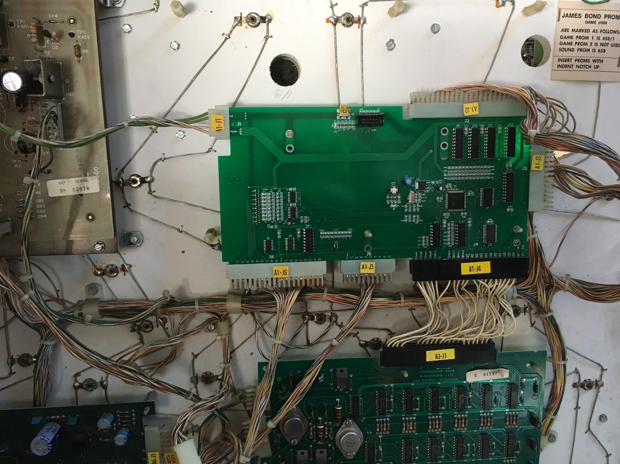
Figure 1 - Ni-Wumpf replacement CPU showing connector designation.

Mounting...
Mounting the new board in place where the original Gottlieb CPU was, is a simple process made only somewhat more complex by the size of the board. Because the new board is so much smaller than the original (about ½ the size), it only mounts on half of the posts available. Using the lower right-most posts, the board presses neatly into place without modification to the existing system. There will be three nylon posts unused above the CPU, and one additional post unused to the left.
The board has two sets of mounting holes on it to allow it to be mounted in a way that best fits the machine it is going into. These are provided to allow the board’s smaller size to best accommodate the length of the power connector and/or the driver board harness. Bot set of holes are equally appropriate.

-WARNING-
-WARNING-
-WARNING-

BEFORE the game is powered up with the new CPU there are several guidelines that must be followed to prevent the board from suffering damage.
First, and foremost; if the inter-board connector harness between the CPU and the driver board (J4) has suffered corrosion damage, the pins on this cable should be replaced. Corroded pins will be brittle, and prone to imminent failure, while the lack of spring tension on a corroded pin will also make for poor contact. Granted, the CPU has circuitry that is a bit more immune to the type of failure that bad pin connectors can cause, it is still very possible to short out this board with a bad driver board, or a bad cable.
Second; a bad display will destroy the new CPU just as readily as it did the old CPU. Please be sure that all of the displays to be used are checked out before you power up the board. This can be a difficult procedure, especially when checking out an unknown display means possibly frying the test CPU if it is bad. Fortunately, there are not that many bad displays that fall into this category. To err on the side of safety is the best approach, and this means not to use a display whose functionality is questionable
Third, the connectors; J5 and J6 are just as likely to be corroded as J4, and the pins, just as brittle. While these connectors cannot seriously damage the CPU because of their condition, it is imperative that they be checked and repaired to attain proper game operation.
Fourth, no connector should be removed from the CPU while it is powered up! This can damage the CPU, especially the display cables. Always power-down the CPU before removing any connectors.

Diagnostics and Bookkeeping
There are two ways to use the CPU to help diagnose the operation of a game; the first is to use the diagnostic self-test button inside the front door of the game. Pressing this puts the game in CPU self test. The second is to use a computer linked up to the CPU to communicate directly with the system to test it’s functionality.

Onboard CPU Self Test
Statistical analysis, option settings, and diagnostics for the CPU board is organized under four separate sub-menus from the main entry into the self test routine. When you first press the test switch inside the game's front door, you should see the displays blank, and the player 1 display show the word SETUP in rough alphanumerics. (I don't want to hear any hassles about how "well" the 8-segment displays in the game display letters, so just keep that off the service call comments!) The SETUP menu is used to set and adjust game specific features. Pressing the test switch again will offer the operator the chance to enter the DATA menu, used for displaying and resetting bookkeeping statistics for the game. The next main menu is for HARDWR, used for testing the operational condition of the various components of the game. The last menu available is the OPTION menu, and like the original CPU, this gives you the chance to set and modify different playing/bookkeeping options common to all the System 80 games. When the test switch is pressed yet again, the game will give the operator the chance to exit the test mode; (“DONE”) and resume game play. To enter into any of the menus currently displayed in the player 1 display, press the replay button on the front door. This will select the option shown, whether it is a menu, or the DONE command.

When a sub-menu has been selected, the player 1 and player 2 displays will begin to show the fields available for that sub-menu, while the player 3 display will show the value of that field. To advance the field displayed, depress the test button. To increment/cycle the value displayed in the third display, repeatedly press the replay button. To zero this value press the test button and the replay button simultaneously. (In this case "simultaneously" means to be pressed together as closely spaced in time as can be expected. The easiest method to accomplish this is to press and hold the replay button, then depress the test button, and then quickly release both.) Selecting the DONE field in a sub-menu, will return the user to the parent menu, clearing the player 2 and 3 displays. To advance onto the next field, after modification, of the value, depress the test button once again.

SETUP
Fields in the SETUP menu will contain customizable settings for the specific game used. In general the fields will at least contain the following variables.

Field Description Possible Values
NUMBER BALLS Number of balls per game. Normally 3 or 5, but not limited.
FIRST THRESH First scoring threshold for player Any value from 10,000 to 990,000
to achieve a credit must be less than other thresholds.
Factory default = 120,000
SECOnD THRESH Second scoring threshold Should be greater than the 1st threshold
If less than this value, or “0”,
thresholding is ended.
Factory default = 180,000
THIRD THRESH Second scoring threshold Should be greater than the 2nd threshold
If less than this value, or “0”,
thresholding is ended.
Factory default = 280,000
HIGH SCORE Highest score to date preset Any value from 10,000 to 990,000
This value is updated at the end of the
game if exceeded by any player.
Factory default = 320,000
AUTO PERCEn Automatically adjusts the 0 (disabled) – 30 percent of games
threshold values up / down played.
based on the average game
score in order to achieve the
set percentage of games that
would award the first threshold
BALL SAVE The amount of time, in seconds, 0 (disabled) – 40 seconds
that the game will grant the player
a “mulligan” for losing the ball
ENABLE 4 HSTD Maintain four different high 0 - disabled; 1 – enabled
scores to date, or only one.
SHOW HSTD Show the high score to date(s) at 0 - disabled; 1 – enabled
game idle.
ENABLE MILIOn Allow the game to maintain and 0 - disabled; 1 – enabled
display scores > 999.990 points.
If enabled, the scores “scroll across
the display. If disabled, a score that
exceeds 999,990 rolls over to “0”,
and any HSTD is lost.
TOTAL TILTS Number of plumb-bob tilts 0 – 5; a setting of ‘0’ will end the
detected in a period of time game immediately. Factory
before the game tilts the ball default = 3.
IDLE ANIMAT Enable/disable idle mode 0 - disabled; 1 – enabled
animation of playfield lamps
between games.
FAST BONUS Speeds up scoring the bonus 0 - disabled; 1 – enabled
at end of ball.
SKILL SHOT <not normally used for a game>
<Game Options> Here begins a list of game specific option settings – these will correspond to the game manual itself for settings regarding DIP switches 20, 31, and 32 on the original Gottlieb CPU.
Table 2 - Game SETUP fields and their meaning

This is the only sub-menu where depressing the replay button, and holding it closed will be detected by the CPU and will auto-increment the following fields; FIRST THRESH, SECOND THRESH, THIRD THRESH and HIGH SCORE.

DATA
The CPU maintains records of all coins deposited, the number of extra games earned, the amount of extra balls given, and the average score that players have made. With that information, it can help the operator set the threshold settings in the SETUP menu. It is also used when the operator enables the CPU to maintain a dynamic set of thresholds based on player skill. In the bookkeeping sub-menu, the following fields are available for interrogation:

Field Description
TOTAL CREDS total number of credits paid for via coin entry
GAME STARTS total number of games started
COINS LEFT number of coins registered through the left coin chute
COINS CENTER number of coins registered through the center coin chute
COINS RIGHT number of coins registered through the right coin chute
TOTAL REPLAS total number of replays awarded
NUMBER SLAMS number of slam tilts detected
NUMBER EBALLS total number of extra balls awarded
NUMBER TILTS number of normal tilts detected
AVERAGE SCORE average number of points scored per game over the time since the last NVRAM reset.
Table 3 - Bookkeeping fields and their meaning

Bookkeeping information is completely reset when a selection is made to restore factory settings (see below).

HARDWR
In the hardware testing sub-menu, the CPU can test the operation of the displays, the lamps, the coils, and the switches. While exercising any of the tests below (except for the switch test), any switch closure on the playfield will interrupt the running test, and terminate it.

Field Description
DISPS Selecting the display test will begin the first half of the display test, which is to count from ‘0’ to ‘Y’ repetitively in every display digit for all of the displays. If you depress the replay switch again during this test you will toggle the test from this half of the test, to the second half, which is to show a marching digit across each of the display digits counting from ‘0’ to ‘Y’ repetitively.

LITES Selecting the lamp test will continuously pulse the lamps on and off for around three minutes before timing out.

COILS Selecting the coil test will cycle through all of the system coils available, including the special coil assignments used via lamp circuits connected to transistor drivers. While the coils are pulsing, the corresponding coil number will be displayed in the status display. Consult your game specific manual for the game being tested to determine the coil assignment number to the playfield solenoid. This exercise will also repeat for about three minutes before timing out. <TOGGLING>

SWITCH In this test, the CPU scans the playfield for any newly detected switch closures and reports the switch assignment in the player 3 display. One second after the last switch is detected, the display will return to show a "0" in the display, indicating that the CPU is scanning for newly detected closures. If two or more switches are depressed at once, the CPU will display them, but you will only be able to see the last switch indication in the display. Be aware that this test cannot determine if any switches have been stuck closed since before the test began, as it can only detect newly activated switches.

SOUNDS Initiating the sound test will output each sound incrementally, from 1 to 15, each time the game start button is depressed. The sound number will be shown in the status display as it is being played. Please note that some sounds will not be interrupted from playing by pressing the start button.

INIT E Selecting this function restores factory defaults to the NVRAM. The CPU will flash the displays when it is done resetting the audits, high-scores, and features. It was determined that the entire diagnostic set-up to the games had gotten just complex enough to justify an option to reset all of the NVRAM settings to the factory default.
Table 4 – Hardware test menu

OPTIOn
If you consult the original game manual for the System 80 games, you will find that all of the parameters that were selectable via the DIP switches on that board are also selectable via this menu, with a few added fields at the end.

Field Description Possible Values
LEFT COINS Left coin counter multiplier. (see table 5 for matrix)
RIGHT COINS Right coin counter multiplier. (see table 5 for matrix)
CENTER COINS Center coin counter multiplier. (see table 5 for matrix)
CHUTE MATCH chute control 0 - allow separate coin
chute control
1 - set coin chute 2 control
to be that of chute 1
CREDIT LIMIT Maximum credits allowed. 0 - 15; 0 enables free play
COIN SOUNDS Play credit tune 0 - disabled; 1 - enabled
SHOW CREDS Show credits 0 - disabled; 1 – enabled
SPECIL CREDIT Special awards credit or 0 - disabled; 1 – enabled
extra ball
SPECIL OVERRD Disable additional Specials and 0 - disabled; 1 – enabled
award a point value for
subsequent specials scored
SPECIL AWARD Point value for above Special 1,000 – 60,000 in increments
Override of 1,000. Factory default =
20,000
SCORE SOUNDS Play sounds when scoring 0 - disabled; 1 – enabled
ENABLE MATCH Match feature 0 - disabled; 1 – enabled
EXBALL LIMIT Maximum number of extra balls 1 – 8; Factory default = 3.
allowed per ball in play. This is
the add-a-ball limit.
HSTD AWARD Award for beating HSTD 0 - no award for beating high
score to date. 1 - three replays awarded
EnABLE ADVnCE Enable expert settings menu 0 - disabled; 1 – enabled
Table 5 - Options settings and their descriptions

Setting Description
0 one coin/credit
1 one coin / 2 credits
2 one coin / 3 credits
3 one coin / 4 credits
4 one coin / 5 credits
5 one coin / 6 credits
6 one coin / 7 credits
7 one coin / 8 credits
8 one coin / 9 credits
9 two coins/credit
10 two coins / 2 credits²
11 two coins / 3 credits²
12 two coins / 4 credits²
13 two coins / 5 credits²
14 two coins / 3 credits
15 three coins/credit
Table 6 - Coin counter multiplier table

- GAME
Continue pressing the start button while in the GAME menu until the game name shown is the one desired, and press the test button to exit the game select menu.
Display Name Game
nOT VALID Setting the game to this forces the operator
to enter a game setting at next power-up
PAnTHE RA Panthera
SPIDER MAn Spiderman
CIrCUS Circus
COUnTE RFORCE Counterforce
JAMES BOnD James Bond
TIME LInE Timeline
PInK PAnTHER Pink Panther
MArS Mars
VOLCAnO Volcano
bLACK HOLE Black Hole
HAUnTd HOUSE Haunted House
Table 8 – System 80 Games

Note: All settings in the game test menu are only saved once the operator navigates to the DONE menu item and exits the test menu.

EXPErT
**CAUTION!!!** setting these fields may cause damage to your game!
Specifically, setting the coil hold time to lock on a solenoid for a minute or two is likely to trigger a warning from Smokey the Bear that only you can prevent forest fires. These fields are for tweaks to your board that will adjust certain timing parameters in how points are scored, how switches are sampled, and how long solenoids are energized. It can be enabled by setting the “ADVNCE” option in the “OPTION” menu above.

Field Description
SCORE LAG TM This the time lag between scoring bonus values when counting down. Unlike the setting below, it affects the pause between subsequent bonuses scored after the multiplier has ticked off. The default value here is – 95 milliseconds.
BONUS LAG TM This the time lag between scoring multiple bonus values when counting down (i.e. within a bonus multiplier), it also affects some of the multiple point scoring when the game would score 5000 points (for example), in a series of 1000 point increments. The default value here is – 70 milliseconds
COIL HOLD TM Number of milliseconds to apply the coil voltage to a coil before subsequently disabling it. The default value is 200 milliseconds.
LAMP ENA TM Length of time to latch the data values into the lamp latch on the driver board. This setting can be extended to enable the CPU to work with some badly designed aftermarket driver boards, at the slight expense of game responsiveness. The default enable time is 15 milliseconds.
SWITCH STR TM Speed by which the playfield switches are scanned. This also affects the display refresh rate. A faster strobe time enables better responsiveness to clean switches, but may cause the CPU to miss detecting dirty switches. The default value is 1000 microseconds.
FLASHING STR TM default value = 220 microseconds
PF ANI STR TM default value = 100 microseconds
ENABLE TDEBUG When trying to debug a scheduling issue with the game code, enabling this setting will display the timer ID in credit window. Default value = 0 – disabled.
SWITCH DUP TM Maximum period of time during which a repeated switch detection will be discarded. By default any switch seen more than once within 60 milliseconds will be ignored.
TIME CALIBR CPU clock calibration timer, when at this menu item, the High Game to Date lamp will flash in 100 millisecond intervals. Putting an oscilloscope to the output line should show a 100 mSecond square wave.
Table 7 - Options settings and their descriptions

Monitor Console
Ni-Wumpf has developed a rudimentary PC (Windows) program to control and diagnose the CPU. It can be downloaded from the corporate website, and once installed, will open communications up to the CPU. Once connected, the connection indicator will turn green indicating that the board is online.
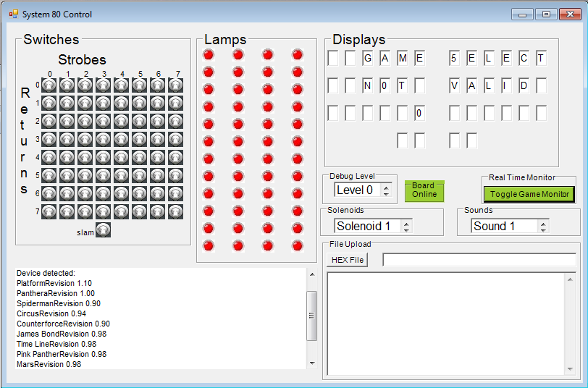
Figure 2 – Diagnostic Console

The output status box will then display the platform revision, and the game revision of the code installed on the board. As shown above the monitor program is separated into functional input / output sections of the CPU, with a status section, and a file upload section.
Toggle Game Monitor – pressing this radio button on the program will command the CPU to continuously send status information back to the PC about the condition of all of the inputs / outputs of the CPU. It will show switch closures, lit lamps, and the display outputs in real time. Pressing it again will turn this mode off, and remove this communications load from the CPU.
Each of the boxes; ”Switches”, “Lamps”, “Solenoids”, and “Sounds” allow the user to view the status of these inputs/outputs on the CPU, and to toggle inputs/commands to the CPU.
Switches - here, the user can simulate switch input to the CPU, as well as to view what switches are detected closed on the playfield. The switch matrix is laid out in a strobe / return matrix that should correspond to the game manual, and the wiring, in the game. I.e. switch ‘70’ corresponds to strobe line ‘0’, and return line ‘7’; the game test button on most System 80 games. A switch is shown to be closed if the image shows a toggle switch with the paddle flipped upwards. This is the best way to determine if there are stuck switches on the playfield while diagnosing switch problems. Additionally pressing the mouse on one of these switches will simulate that switch’s closure to the CPU. I.e. clicking on switch ‘70’ will put the game into self-test mode.
Lamps – this box shows the status of lamps on the playfield (again, when in monitor mode). When the image is red – the lamp is off; green – on. Like the switches, the lamps are shown in a matrix that corresponds to the logic on the driver board. Each row of lamps corresponds to a latch on the driver board. If the user hovers the mouse over the lamp image, the program will display what lamp number corresponds to that status lamp. Similarly, if you mouse-click on the image, it will command the CPU to toggle the lamp on / off. When diagnosing the driver boards with this box, it is important to note that the dialog hint for the lamp number, for example L3, which corresponds to the “shoot again” lamp, will correspond to the Q4 transistor on the driver board. The same as described in the game manual.
Solenoids – this dialog box is used to energize the coil shown in the window. Clicking the mouse in this window will command the CPU to send a coil pulse to the driver board. The coil selection is changed by using the arrow keys to the right of the dialog box.
Sounds – as above, this dialog box is used to play that sound shown in the window. Clicking the mouse in this window will command the CPU to send a sound output to the sound board. The sound selection is changed by using the arrow keys to the right of the dialog box.
Debug Level – There are several debug levels available for reporting status / error conditions on the CPU back to the program while the game is being played or tested. When entered, the CPU will send messages back to the status window regarding debug activity on the CPU. For example, setting this value to any debug level of 1 or above will report on watchdog timeout activity that corresponds to a lack of activity on the playfield that may be as a result of a ball being stuck.
Level 1 debugging – report switch closures, and identify what switches are detected that do not correspond to game logic.
Level 2 – not used.
Level 3 – report scheduling activity for events occurring in the CPU, and report serious memory overflow errors (extremely uncommon, unless writing game program code).
Displays – this box is an output section that shows that the CPU thinks it is sending to the displays. There is no input allowed in this box. However, it should be noted that if the CPU thinks it is sending a character to the displays that is not showing correctly on the displays, it may indicate a problem with the display. Also it should be noted that the outputs from the CPU may show characters on the diagnostic tool that may be confusing because of the limitations of the displays. I.e. a ‘6’ will be the same segment character as a ‘G’, a ‘5’ is the same as an ‘S’, etc.
Please note! The game diagnostic program is limited in it’s own error detection and correction. It may loose connectivity to the CPU when in monitor mode, and need to be restarted in order to correctly sync up with the board. This will not damage the board.

Updating Code.
The Ni-Wumpf CPU is designed to be field upgradable for the code supported on it - not just the game code, but also the basic System 80 environment. Update files are in Intel HEX format and can only be obtained from the official Ni-Wumpf website. To “patch” the CPU, hit the “HEX File” radio button, and use the subsequent dialog box to select the file to upload to the CPU. This process may take anywhere from a few moments to a few minutes depending on the size of the file sent.
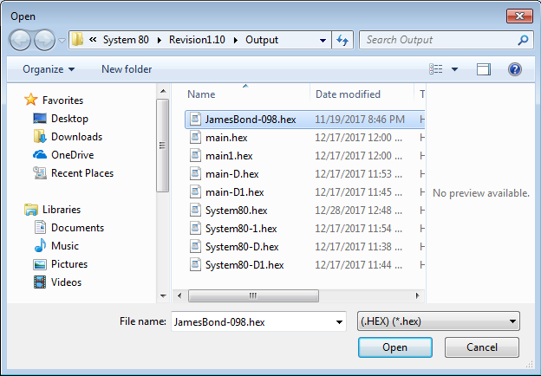
Figure 3 – Upload file Selection

Once selected, the file name will be shown in the File Upload dialog box, as well as the HEX content of the file. Upon completion, the status box will indicate that file upload is complete and that the updated image has been flashed to memory, and the displays should reflect that status as well. It should be noted that when the operator updates the “main” code segment for the CPU, the board will reboot, when it does so, the USB cable should be disconnected, and the monitor program restarted in order to sync up with the board again.
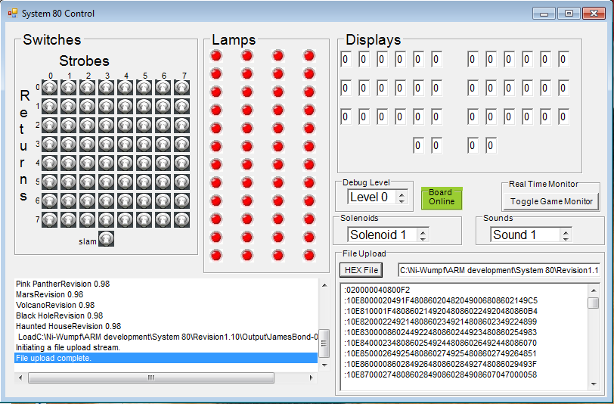
Figure 4 – Patching “James Bond” code

Troubleshooting
Isolating what section of the CPU may be damaged in the case of operational failure will be necessary before any corrective action can be taken. The table below is far from complete, but is intended to help the operator isolate the faulty component / describe the correct procedure to help diagnose the board performance. Should some symptom exist that does not fall into any of these categories, you should reference the website (www.ni-wumpf.com) for further assistance and contact information.
The CPU should normally blink once during power-up to indicate that it is operational. Following this single flash, the game should briefly show the platform code revision, and the game revision in the displays, and enter idle mode immediately - alternating displaying the high score to date, and the last game score.
Symptom Possible Cause
No LED activity or LED lit continuously on power-up. | The program memory has been corrupted, or the LED is damaged – return to factory.
LED blinks once at power-up. | Normal operation

Front door switch(es) do not register / game will not start / game test button does not register | The most common error in repairing old games. Examine the front door for bent leaf switches (coin chutes), free play buttons (no longer needed), cut or spliced wiring. Remove any hacks / modifications that could damage the CPU. The front door is ground, and if switch strobe leaf switches contact this, it will eventually damage the CPU. An oscilloscope or logic analyzer will confirm damage to Z4 on output lines on pins; 4, 5, 6, 7, 9, 10, 11, and 12.
Lamps do not operate that correspond to one or more strobe columns (1 to 12) | Z8 may need to be replaced – this surface mount chip buffers outputs to lamp columns. This chip is not normally damaged.
Solenoid 1, 2, 5, 6, 8, or 9 continually energized or will not energize. | Z15 may need to be replaced – this 7406 buffers solenoid outputs to solenoids 1, 2, 5, 7, 8, and 9 on the driver board.
Solenoid 3, 4, or 7 continually energized or will not energize. | Z14 may need to be replaced – this 7406 buffers solenoid outputs to 3, 4, and 7.
The same segment(s) on all digits in Display Bank A (player 1 and player 2) are stuck on or off. | Z9 may need to be replaced – this 74LS240 buffers segment outputs to display bank A
The same segment(s) on all digits in Display Bank B (player 3 and player 4) are stuck on or off. | Z10 may need to be replaced – this 74LS240 buffers segment outputs to display bank B
The same segment(s) on all digits in Display Bank C (timer/bonus and credit displays) are stuck on or off. | Z11 may need to be replaced – this 74LS240 buffers segment outputs to display bank C
A digit in the same position on all display banks (for player 1, player 3, and the bonus/timing display if present) shows brightly or does not light at all. | Z12 may need to be replaced – this 74LS240 buffers outputs for digits 1 through 8
A digit in the same position on all display banks (for player 2, player 4, and the bonus/timing display if present) is showing brightly or not lit at all. | Z13 may need to be replaced – this 74LS240 buffers outputs for digits 9 through 16
One or more switches are not recognized – corresponding to switches on a specific return line. | The return buffers are SMT components, and this may indicate a factory repair
CPU crashes/sporadically resets during game play | Generally, this is not a CPU problem, but rather an associated problem with the +5 voltage level. The problem can normally be reproduced by causing the CPU to energize a solenoid, while simultaneously energizing a non-CPU controlled solenoid (such as a bumper). This will stress the power supply enough to drop-out the voltage regulator or surge the ground. Check that all solenoids are the correct part number and that the snubbing diodes across them are working. Check for good ground connections at the power supply header pins. Check that the solenoid drive transistors are not “leaking”. Check the connector between the CPU and driver board for good connection. Check the power supply voltage regulator for a solid +5 volts.
Table 8 – Troubleshooting Chart

Warranty

The Ni-Wumpf replacement System 80 CPU is warranted against manufacturing defects and premature component failure, known as infant mortality, for up to 90 days after the date of it’s purchase. For this reason, it may be prudent to keep a copy of the receipt for the board handy, in case the need should arrive to lend some credibility to your claims as to when it was actually purchased. In the unlikely event that a part should fail on the board within this time frame, simply package up the board, with a copy of your receipt, and return it to the factory address mentioned on our website, with some note of explanation as to why we are receiving this unexpected gift. Your CPU will be repaired or replaced and returned to you as quickly as possible.
Failure of the system within the warranty period due to abuse, incorrect installation, or faulty game components, is not covered by this warranty. The purpose of this warranty should be quite clear: We are willing to accept responsibility for manufacturing defects of the boards we are building, and feel that 90 days is a sufficient period to determine if such a defect may exist. We are not willing to accept the responsibility of others who may install this board into a game that may be broken enough to cause the CPU to fail.

Returning Your Board for Repair
To determine the steps required to repair your CPU, it is best to gather the information necessary to get the board serviced, whether by yourself or the factory. First of all, be certain that the CPU is actually broken before calling it in for service, and the best way to ascertain this is to consult this manual in detail under the configuration and troubleshooting sections. Next, armed with the confidence that a smoking chip is indeed reason for repair, contact your distributor or refer to the website below to determine what steps to take next. If you intend to do the repair yourself, he will be the person with the parts necessary to replace the chips you deem necessary. He will also be the person with the knowledge of what repair costs the factory will be charging if you wind up sending it in for repair (and in the case that the company address should change, he will know what the current address for Ni-Wumpf will be).
Repair of the Ni-Wumpf CPU is performed at the factory for all SMT failures. However, because the board design is targeted toward isolation of SMT component by “edge” buffer components, it should also be reasonable to undertake repair of the these components yourself should you feel capable of doing so. Most of these edge buffers are freely available at electronics supply stores, also these parts may be purchased directly from the factory or your distributor if they are determined to be at fault. In the case of board repair being sent to the factory, return the board to our address mentioned on our website with a note describing the problem. Repair costs may be required in advance and may be determined by contacting the factory beforehand.

Ni-Wumpf LTD.
www.ni-wumpf.com

Schematic supplement for the
Ni-Wumpf System 80
replacement CPU

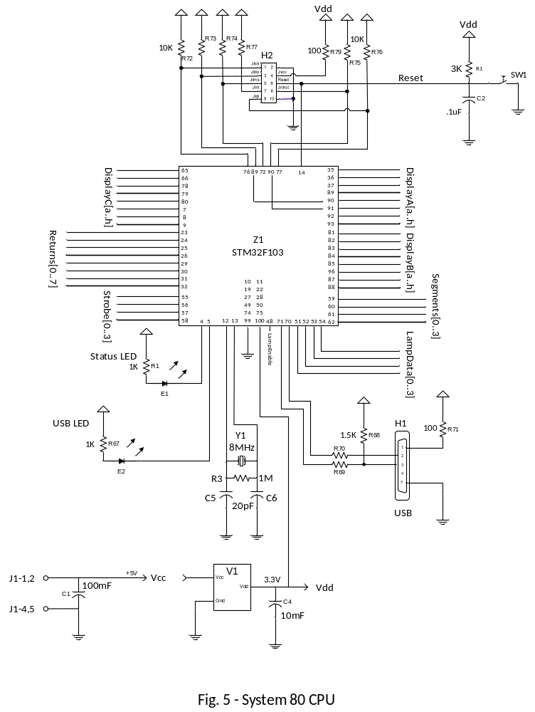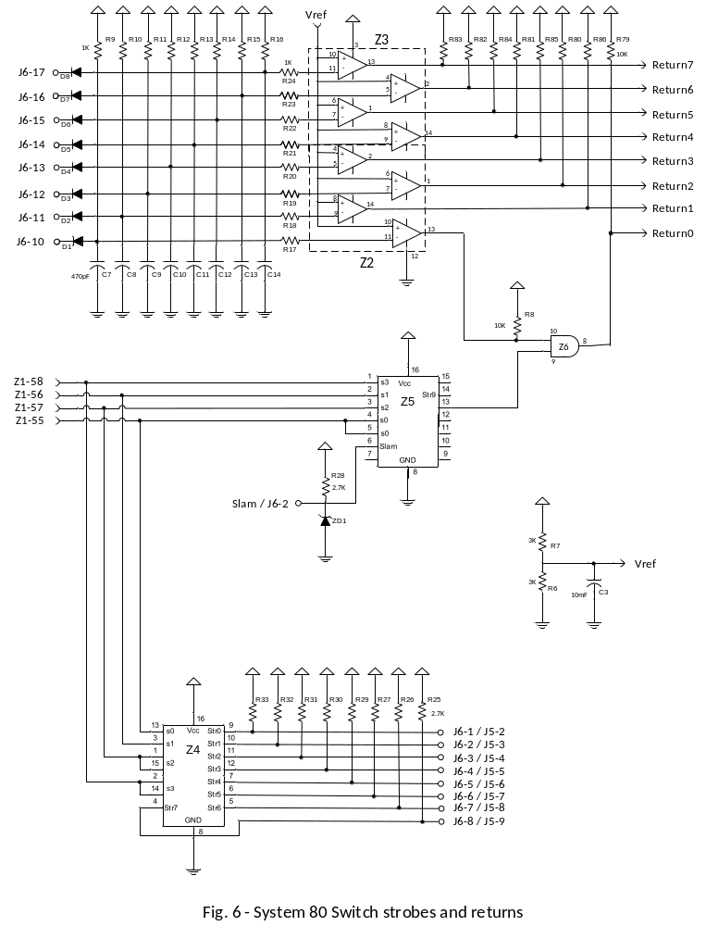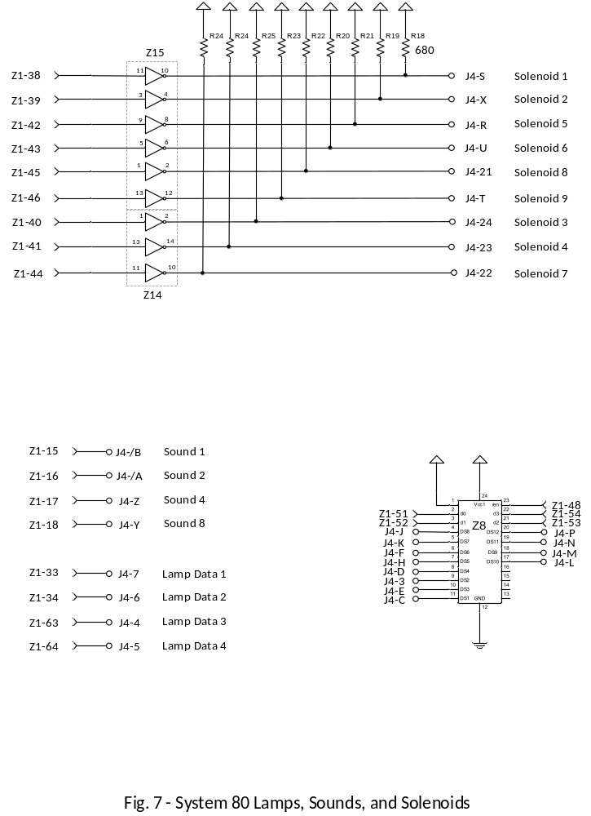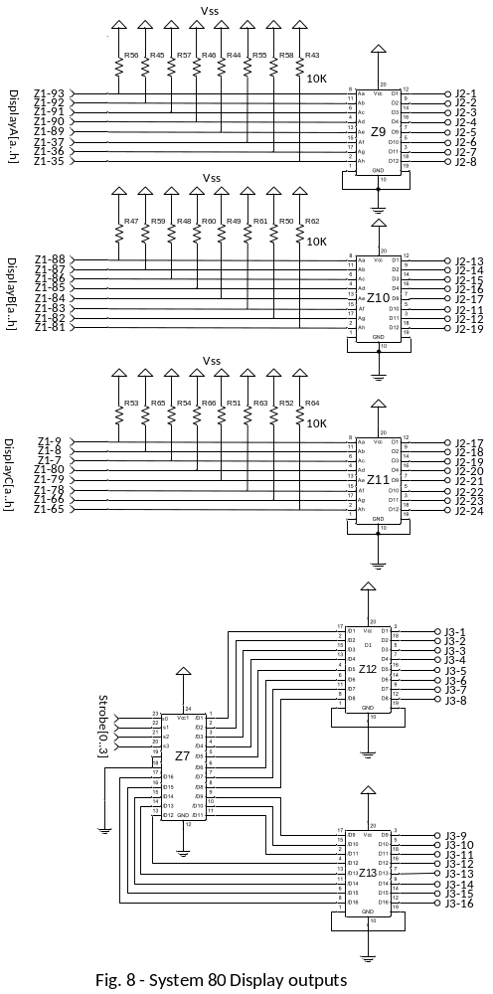

Designator | Qty | Description
R3 | 1 | 1M,1%,1/8W,0805
R68 | 1 | 1.5K,5%,1/8W,0805
R1, R4, R6, R7 | 4 | 3K,5%,1/8W,0805
R25, R26, R27, R28, R29, R30, R31, R32, R33 | 9 | 2.7K,5%,1/8W,0805
R34, R35, R36, R37, R38, R39, R40, R41, R42 | 9 | 680R,1%,1/8W,0805
R2, R9, R10, R11, R12, R13, R14, R15, R16, R17, R18, R19, R20, R21, R22, R23, R24, R67 | 18 | 1K,1%,1/8W,0805
R8, R43, R44, R45, R46, R47, R48, R49, R50, R51, R52, R53, R54, R55, R56, R57, R58, R59, R60, R61, R62, R63, R64, R65, R66, R72, R73, R74, R75, R76, R77, R79, R80, R81, R82, R83, R84, R85, R86 | 39 | 10K,5%,1/8W,0805
R71, R78 | 2 | 100R,5%,1/8W,0805
R69, R70 | 2 | 22R,5%,1/8W,0805
C5, C6 | 2 | 20pF,50V,5%,C0G,0805
C2, C15, C17, C18, C19, C20, C21, C22, C23, C24, C25, C26, C27, C28, C29, C30, C31, C32 | 18 | 10nF,50V,10%,X7R,0805
C7, C8, C9, C10, C11, C12, C13, C14 | 8 | 470pF,100V,5%,C0G,0805
C1 | 1 | 100uF,16V, 2000Hrs@85℃
C3, C4 | 2 | 10uF,16V, 1000Hrs@85℃
D1, D2, D3, D4, D5, D6, D7, D8 | 8 | 80V,200mA(DC),SOT-23-3
ZD1 | 1 | 5.1V,225mW,SOT-23-3
SW1 | 1 | SPST-NO,24V,50mA
H2 | 1 | 2*5 pin,pitch2.54mm,180°
E1, E2 | 2 | red,2V,54mcd,0805
Y1 | 1 | 8MHz,20pF,HC-49/US
H1 | 1 | USB,Mini USB-B,90°
Z1 | 1 | STM32F103RBT6,LQFP-100
Z9, Z10, Z11, Z12, Z13 | 5 | SN74LS240N,PDIP-20
Z7 | 1 | CD74HCT154M,SOIC-24
Z8 | 1 | 74HCT4514D,652,SO-24
Z14, Z15 | 2 | SN7406N,PDIP-14
Z5 | 1 | SN74LS138DR, SOIC-16
Z6 | 1 | SN74ALS08DR,SO-14
Z4 | 1 | SN74LS156N,PDIP-16
Z2, Z3 | 2 | LM339MX,SOP-14
V1 | 1 | LF33CDT-TR,D-Pak

Table 9 – Bill of Materials for the Ni-Wumpf CPU

Lighning strikes not included.
As noted previously, the code supplied with the Ni-Wumpf CPU is not always identical to the operation of the original Gottlieb code. One of these intentional coding changes was a direct request from operators that have these games on location. This is the case of the “special” routine on several of the games. In all games where the prerequisite amount of unique combination of challenging shots have been achieved, the player is awarded with the chance to score a “special”. On some of the tables, however, the game may then proceed to reset the lights, rollovers, and drop targets necessary to collect that special more than once in the course of one ball. With the original CPU however, while the “special” lamp may light yet another time, the game will not award a second special. One of the changes made to the code was to correct this operational “flaw”, and enable the player to achieve as many “specials” on one ball as he is capable of scoring. However, when these games are used on location, this may result in unacceptable earnings loss. Therefore, to override this software “feature”, setting the “SPECIL OVERRD” option setting will enable the alternate “special” award for all subsequent specials awarded. In this mode, upon completion of a second “special” within a single ball playing time, the award is changed from the default of an extra game or ball, to one of adding the value set for SPECIL AWARD (factory default of 20,000 points) to the players score.
No credit(s) are given until the second coin is inserted.
First coin gives one credit. Second coin gives two credits, unless a game has been started, in which case it acts as if it were the first coin of two and only gives one credit.
No credit is given until the third coin is deposited.

